# INTRODUCTION

1.1 Salesforce is thecustomer platform design to help you sell, service, market,loans , analysing etc....

In this property management using salesforce can help customer by giving discount ,loans and tracking ideas etc..

1.2 PURPOSE:

i) Assist owners in creating budgets.

ii)Advertise rental properties.

iii)Collect rent

# Problem definitions and design thinking:

2.1 Empathy map

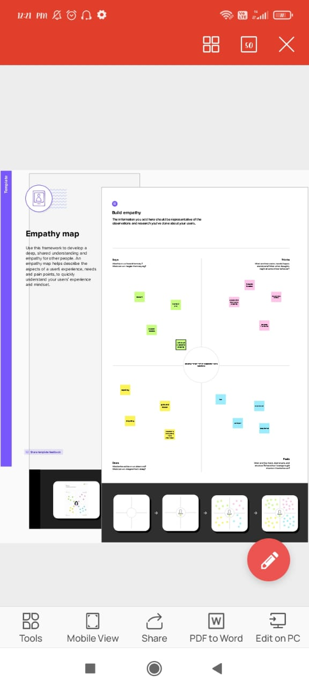

2.2 Ideation & Brainstorming map:

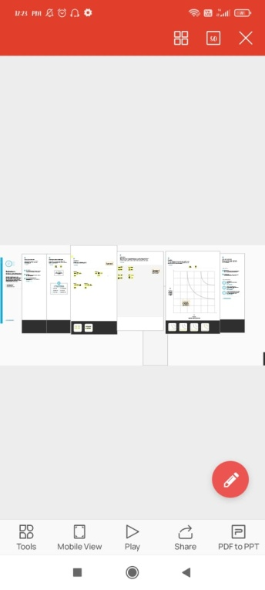

# RESULT:

3.1 data model:

|  |  |
| --- | --- |
| Object name | **Field in the object** |
| Obj 1 | |  |  | | --- | --- | | Field label | Data label | | loan | number | | Product | text | |
| Obj 2 | |  |  | | --- | --- | | Field label | Data type | | rent | number | | house | text | |

|  |  |
| --- | --- |
| Oject name | Field in the object |
| Object 3 | |  |  | | --- | --- | | Field label | Data type | | buy | text | | things | Lookup | |

3.2 activity and screenshot:

Sign to the salesforce

Beside thec the home tab , click the object and create the object custom such as buy, loans, rent

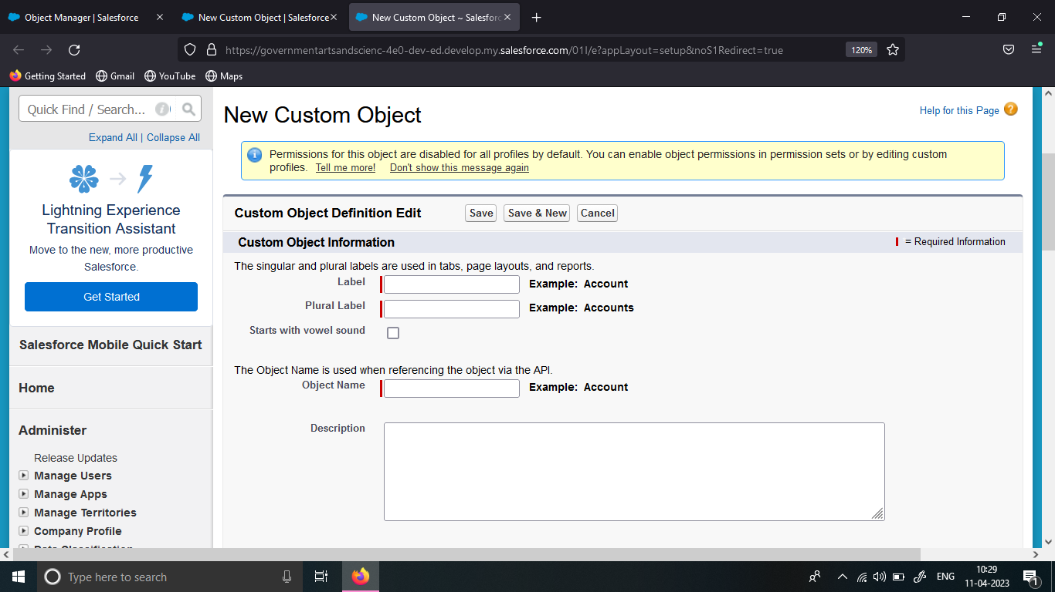

Click the above custom object to create it.

After completing the salesforce create lighting tab.

To create lighting tab

Go the the setup and type tabs in the quick bar

Click on the tabs and new

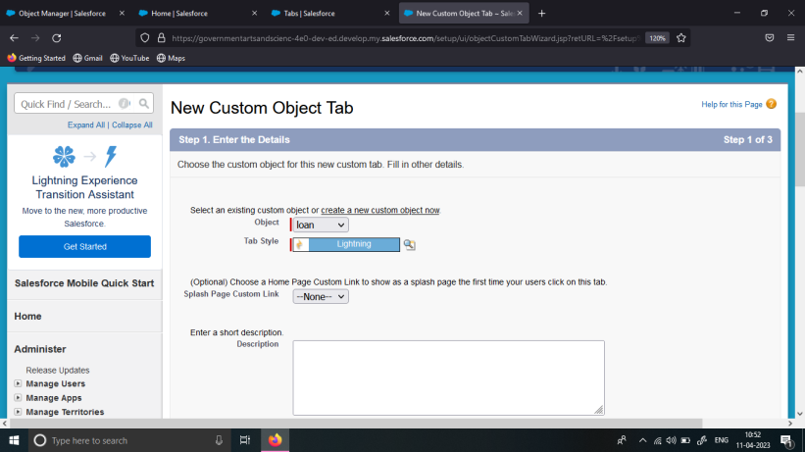

Click the lighting option for the tabs;

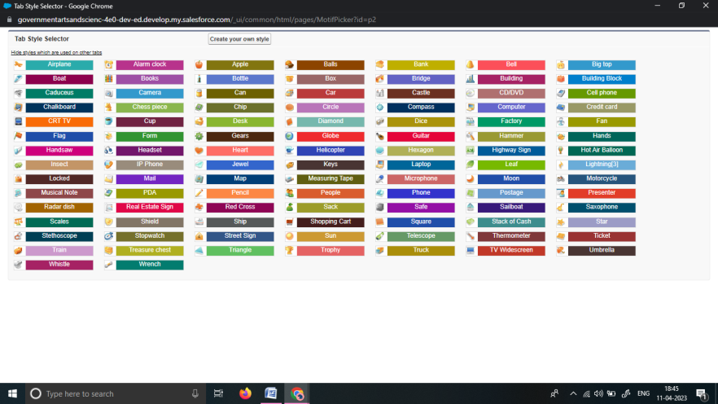

Select object > tab style >next default > keep the default > save.

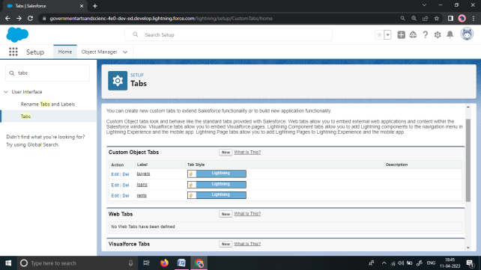

The tab is created all the three object such as loan rent buy.

To create the lighting app

Go to the setup > search app manager in quick find > select the app manager > click on thr new lightining app.

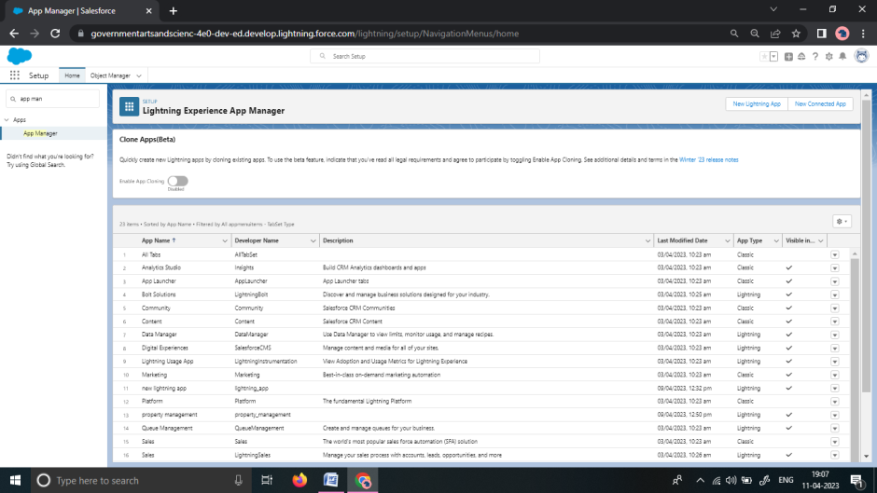

Type the app name >next > default

Enter navigation items such as lead , buy, rent, platform user

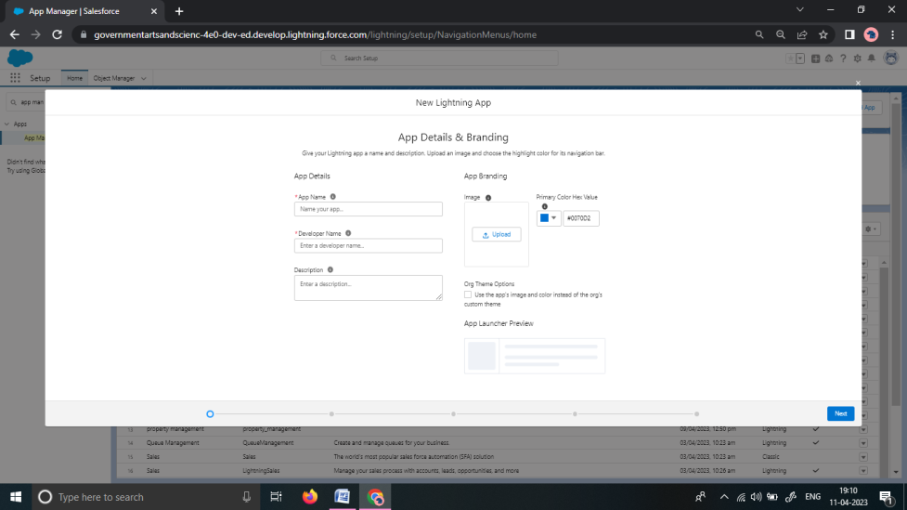

To add navigation items select items in the search bar and arrow key .

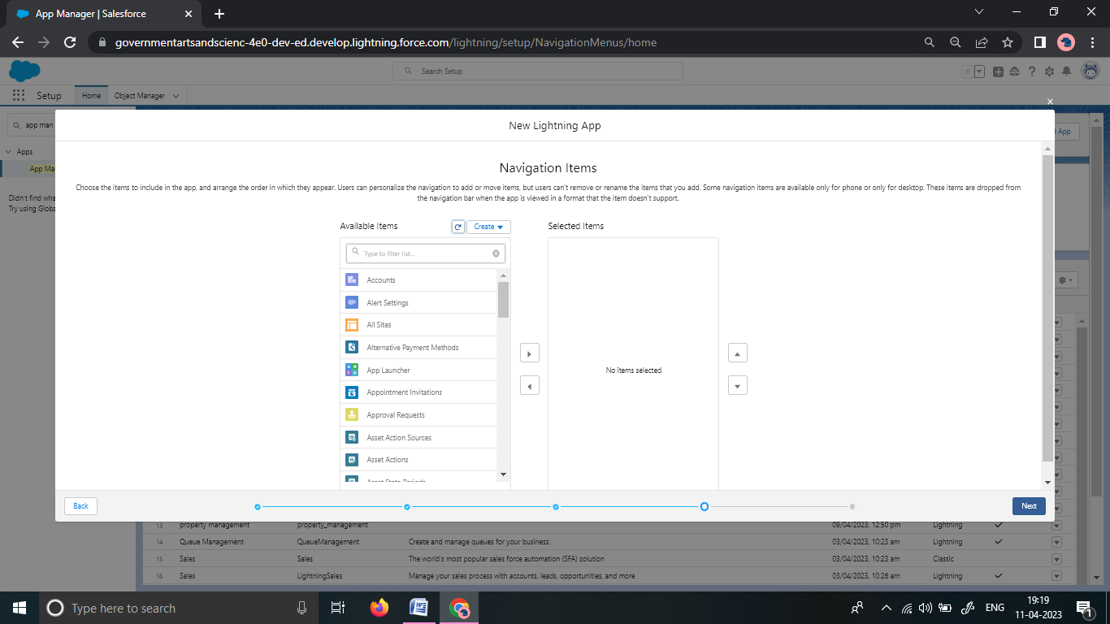

Click next to add user profile

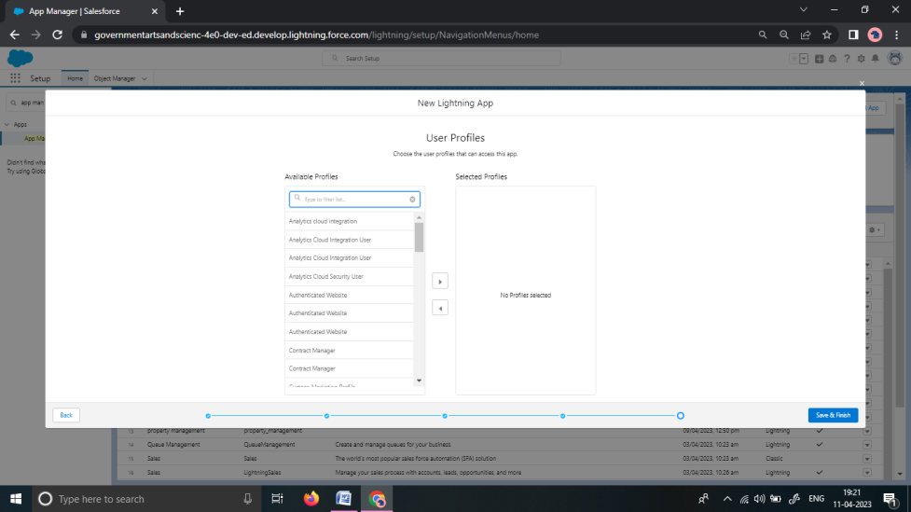

To create the lead field:

Go to the setup > click on the object manager > tyoe the object name in the search bar > click object .

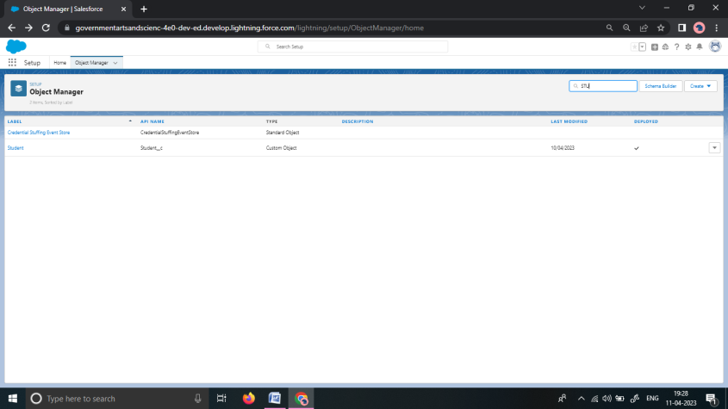

Now click on the FIEDLS & RELATIONSHIP:

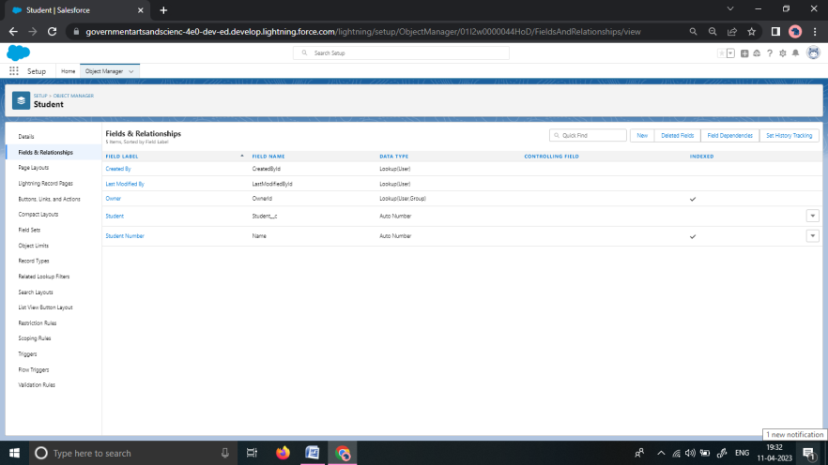

Fill the the label name > next > next > save.

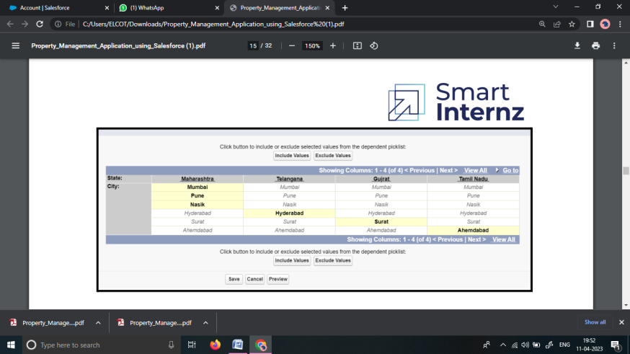

Create the field for rent, loan , buy and save them all .

To create the New profile:

Go to the setup > type profile in the quick bar > click on the profile

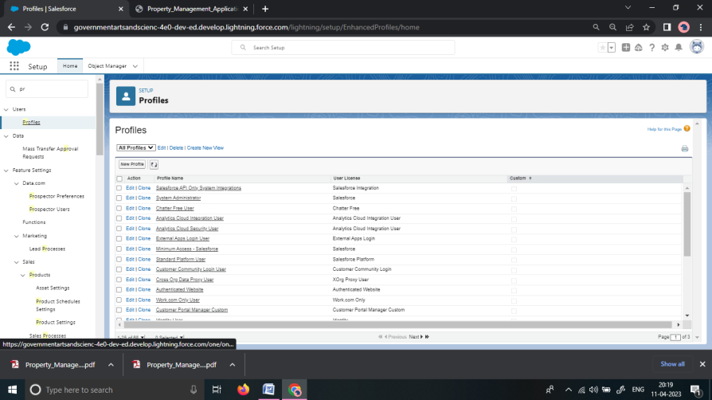

Clone on the desired profile > enter profile name and save it.

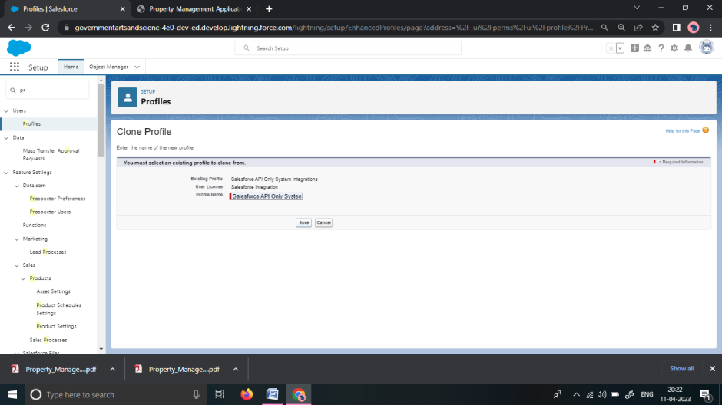

Click edit on the profile page then edit it

Then scroll down the custom object permission and give all access permission and assign them.

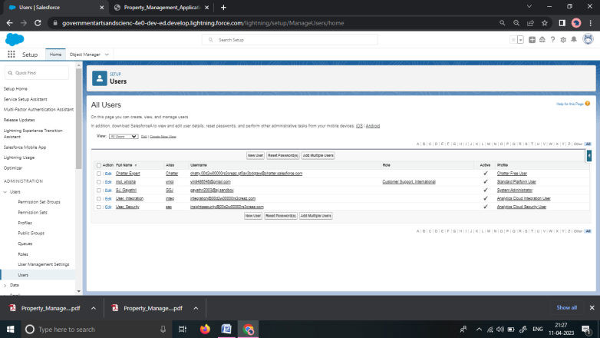

To create the users:

Go to the setup > in the quick bar search users > select users > click new user.

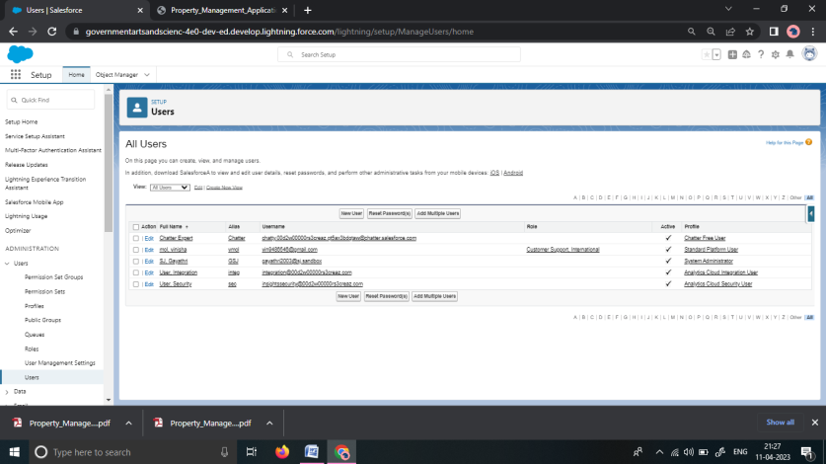

Fill the ( first name , last name , alias , email id , user name , role , profile ) > save it.

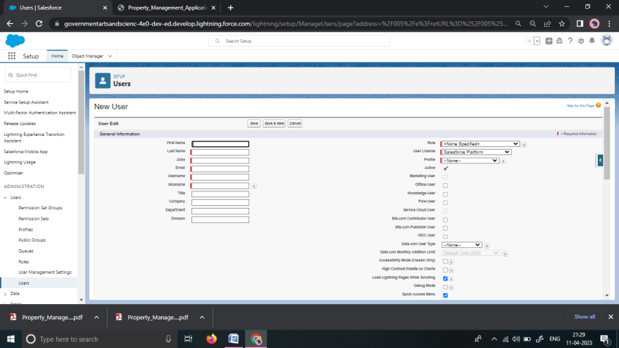

To create the permission set:

Go to setup > type permission sets in the quick bar > new.

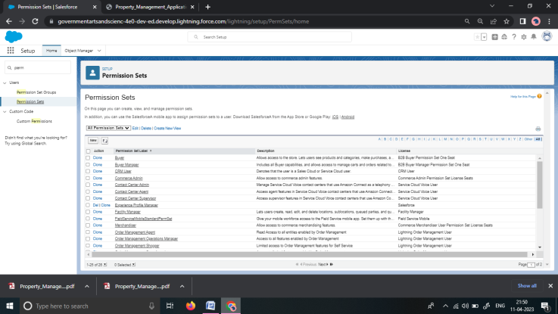

Enter label name > save.

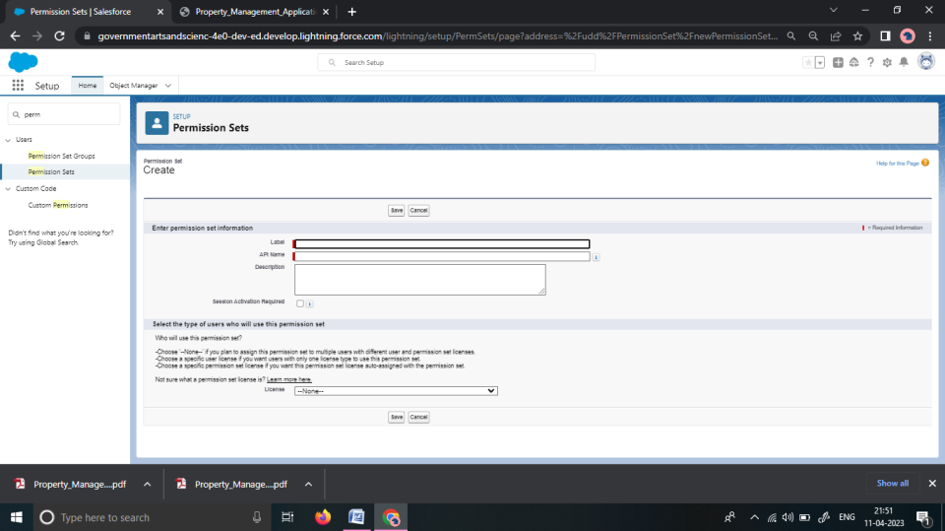

After saving the permission sets click on the manager assignment

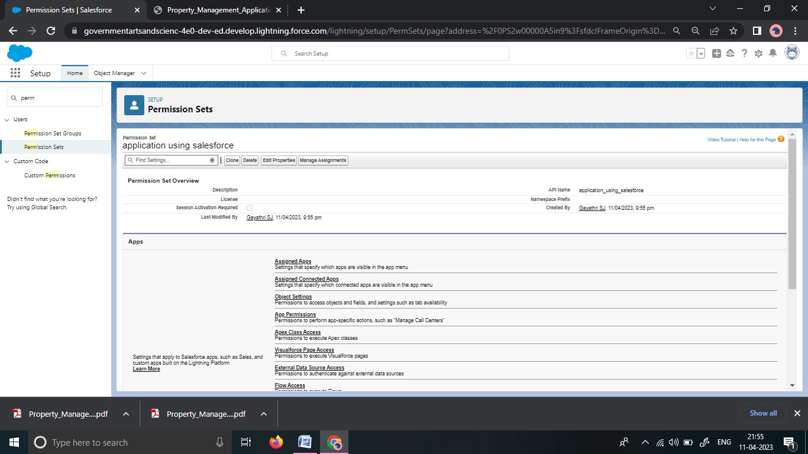

Click on the add assignment

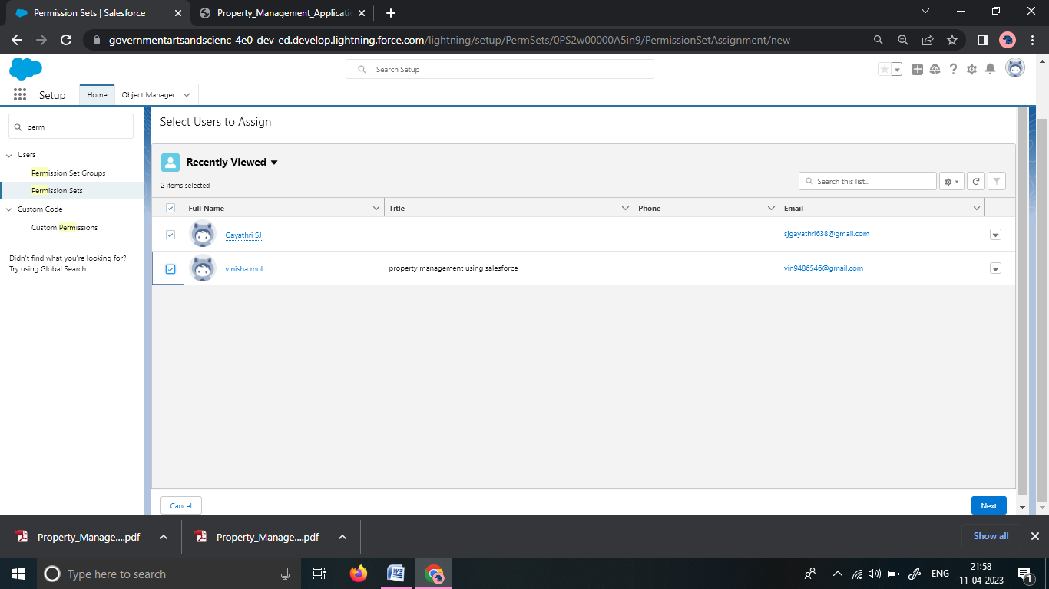

Now select all and save

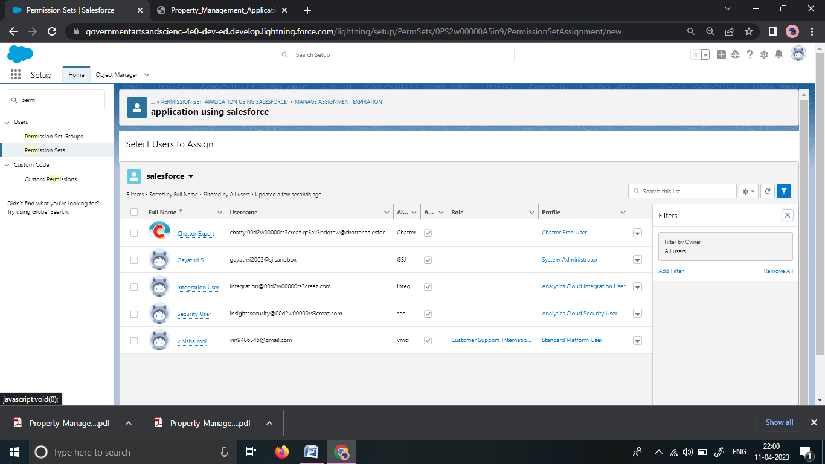

Go to the permission and access asll the permission sets.

To crate OWD settings:

1. Setup use te quick find bar to find sharing settings
2. Click edit in the organisation
3. For each object select the default you want to give to everyone
4. Access using for hierarchies

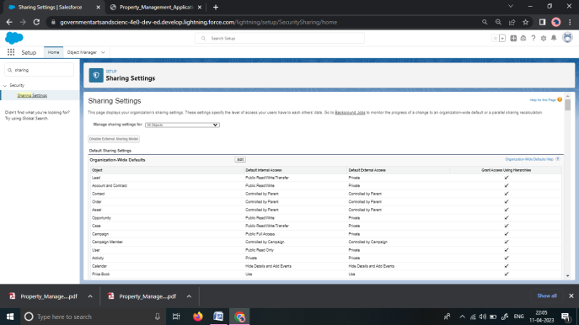

Click on the edit for internal and external

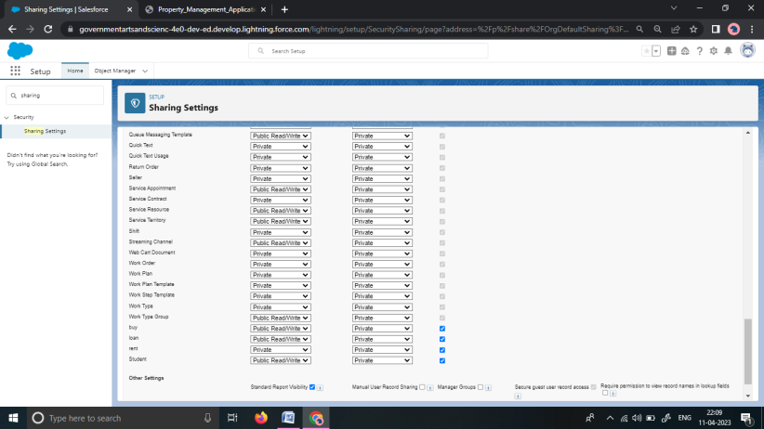

This is the setting is for all user which can be created.

To create report

Go to the app > click on the report tab

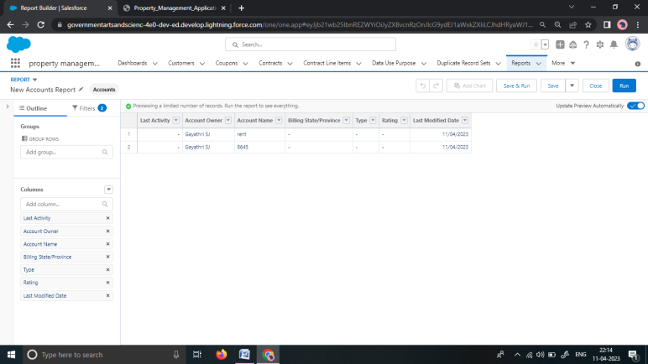

Click the new report

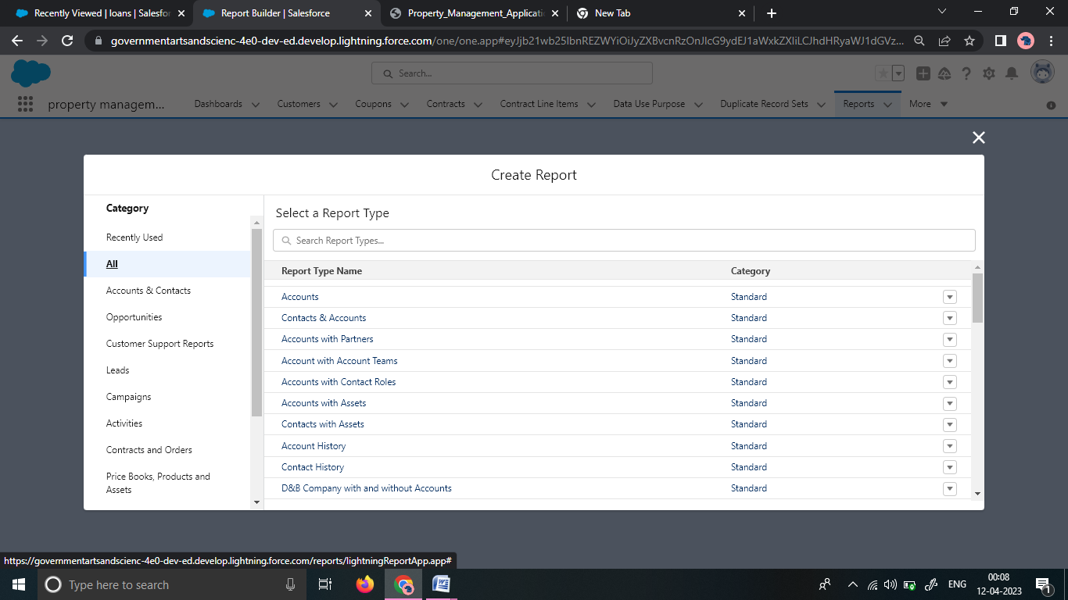customize the report then save it.

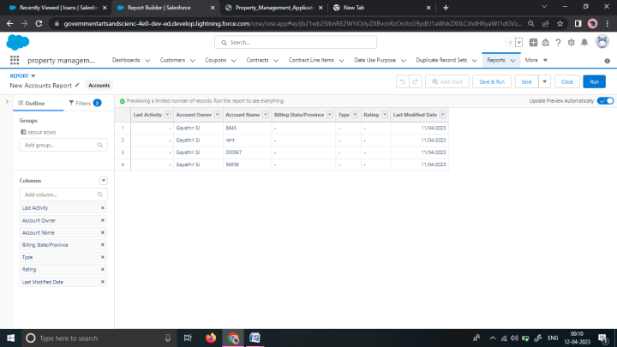

Create the report for the loan greater than equal to 5000$.

To create dashboard:

Go to the app launcher and select the dashboards

Select the components 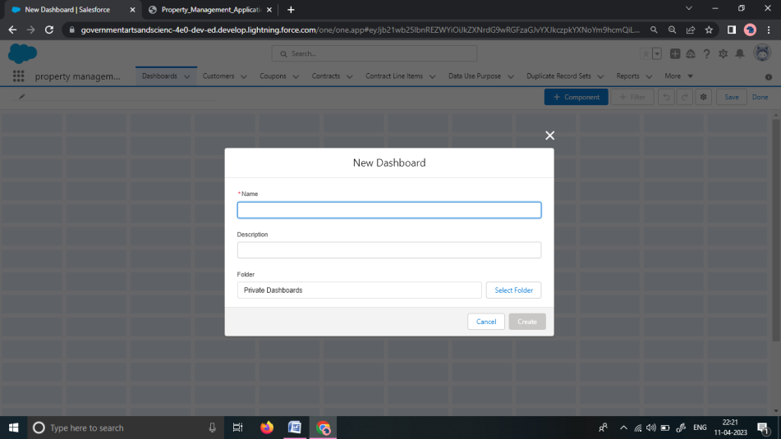

Select the folder with new lead

Select the format you want to display display chart

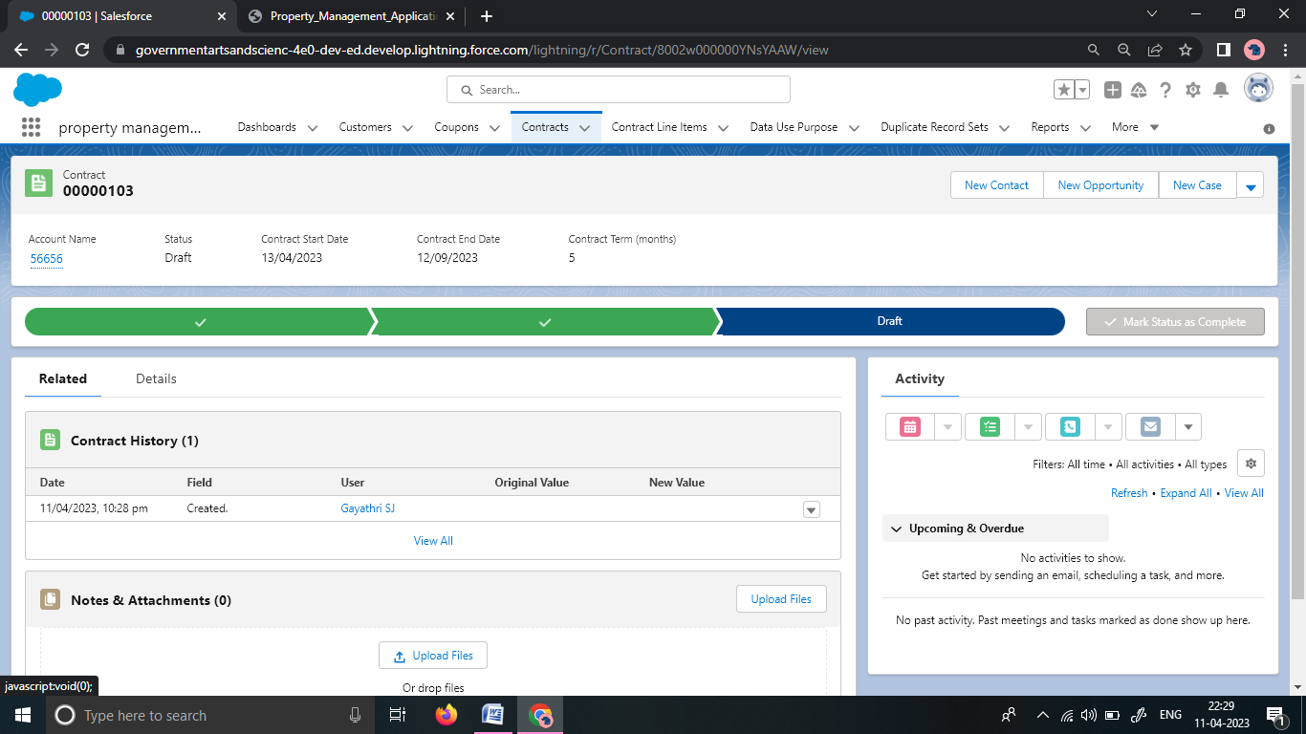

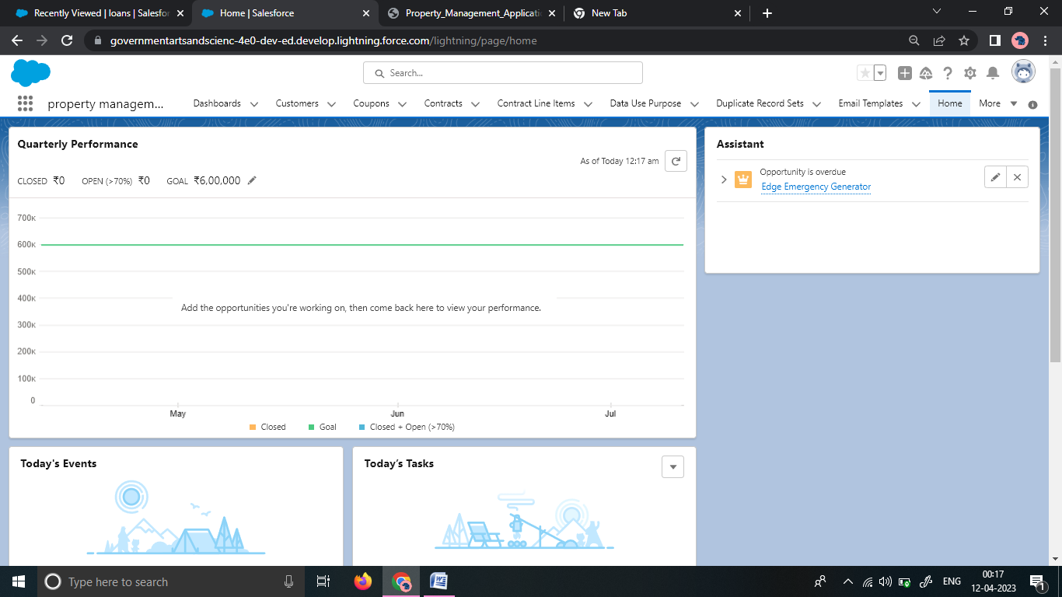

Thus the dashboard is created.

Trailhead profile public URL:

Team Leader : vimol2

Team member 1: gaysj

Team member 2: ii17s

Team member 3: Role2109

Advantages & Disadvantages:

Advantages :

* + - High data security
    - All data in one place
    - Better customer data management
    - All terms tenants
    - Increase and maintain the value of your rental property
    - Improved revenue management

Disadvantages:

* It can be difficult to apply to large and complex organisation.
* It does not provide any tool and technique for managers.
* Lack specialists that have a deep understanding of property management business and its priorities.

Application :

* Property brokers
* Real estate investors
* Shopping mall
* Strip mall
* Corporate companies

Conculsion :

This application is applicable for all the customers and owners. Everyone can use this application . It can give a new way to buy and sell the land.

Future Scope :

In Future , this type of many application are programmed and developed for the customers and owners.

There is a chance to produce an advance level of the Loan and Rents.